Grade 4

Waves and Information

Experience 1

What is a wave?
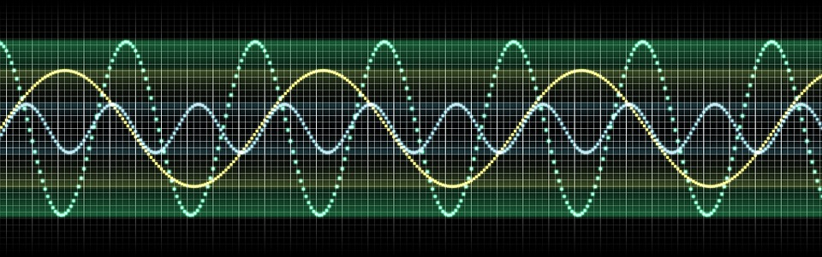
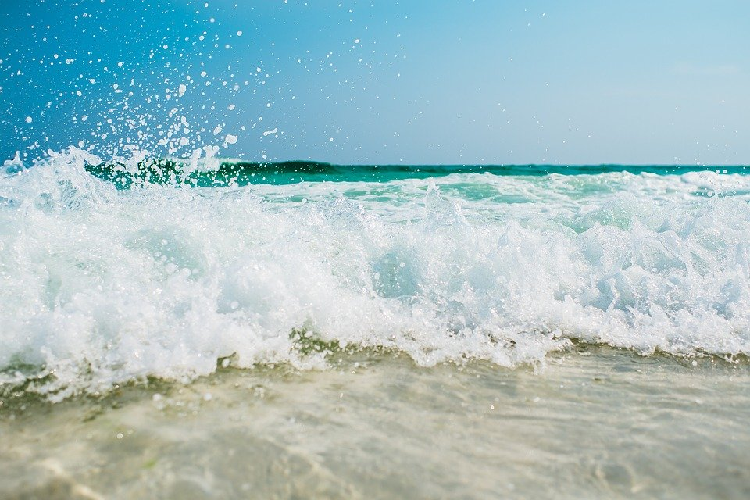

Draw and write about the wave you created. Show someone the wave and your description.

What kind of wave did you create?

___________________________________________________________________________

___________________________________________________________________________

___________________________________________________________________________

What is a wave? (What pattern of motion is a wave?)
___________________________________________________________________________

___________________________________________________________________________

___________________________________________________________________________

